Lab Report 2

Vũ Đức An – 20215174

1. Assignment 1:

* At the beginning:





* After the first run:





* After the second run:





* Text segment:

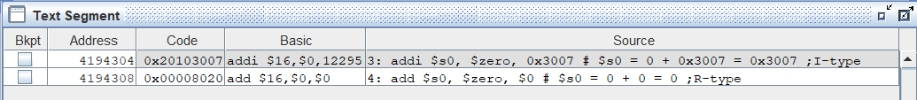

* + addi $s0, $zero, 0x3007 ( addi $16, $0, 12295 )
    - op: 001000 (8)
    - rt: 10000 (16)
    - rs: 00000 (0)
    - immediate: 0010 0000 0000 0111 (0x3007)
* Machine code: 0010 0000 0001 0000 0010 0000 0000 0111 (0x20103007)
  + add $s0, $zero, $0 ( add $16, $0, $0 )
    - op: 000000 (0)
    - rd: 10000 (16)
    - rs: 00000 (0)
    - rt: 00000 (0)
    - shamt: 00000 (no bits were shifted)
    - fn: 100000 (32)
* Machine code: 0000 0000 0000 0000 1000 0000 0010 0000 (0x00008020)